Black Box Testing Design Intended for Vehicle Surveillance and Tracking
N. Jagadish Kumar¹, S. M. Udhaya Sankar², B. Muhesh Kumar³, A. Praveenkumar⁴, R.G. Ranjith⁵
^{1,2,3,4,5}Department of Information Technology, Velammal Institute of Technology, Panchetti, Chennai, India.
¹Jagadishiva@gmail.com, ²udhaya3@gmail.com, ³bmuheshkumar@gmail.com, ⁴apraveenkumar720@gmail.com, ⁵ranjithganesh20.rg@gmail.com

Abstract— Nowadays, when a car is in a critical position, many other autos also have accidents, often resulting in fatalities. The populace has always needed protection and safety. In order to detect risky driving, a car alarm app requires an accelerometer and gyroscope. However, the surveillance and tracking features need to be added to current systems. With cloud services controlling the rapidly expanding electronic specific product, the internet of things (IoT) has been dictating the technology era. As a result, a mechanism for maintaining security and preserving traffic information must be created. IoT is being used to protect cars and their occupants against issues like burglary and repossession. The user can manage the vehicle's combustion and, if necessary, switch it off.
Our approach focuses on gathering data from crash recorders about how the vehicles moved before and after a collision. When an accident occurs, the police control center or rescue squad will be notified immediately with the auto identification number and individual contact information. The collision site can be quickly found by the authorities thanks to the message's origin. The relevant measures will be taken after the position has been verified. In a second scenario, including uncertainty, many vehicles with keyless entry systems, including door lock security systems, experience several issues as a result of the automated locking mechanism. The lock cannot be opened if. This initiative may offer a remedy for this predicament. This is possible by utilizing the GSM network.
The effectiveness of our technology in accurately identifying incidents, determining their severity, and also locating vehicles showed promise. It is a cutting-edge system that has a security system. We can turn the engine ON/OFF through the mobile app. Our car can be tracked around the clock. To analyze the backup data, a graphical interface was eventually created. This technology is comparable to a black box in an airplane that uses a particular procedure to capture all flight data into the black box.
Keywords— IoT, Sensors, black box, Theft, GSM, GPS.

Introduction
All the people around the world rely heavily on cars as well as the infrastructure of the highway system to travel from one point to another. Since the dawn of civilization, human development has included the use of conveyance. Even if technology has improved significantly, the accident detection and prevention methods still in use were stable procedures like speed limit signs and road markings that were put in place generations earlier [1]. The World Health Organization estimates that more than one million individuals pass away every year as a result of incidents involving transportation. The frequency of fatalities increases as a result of inadequate help given to accident victims. As a result, the study team, as well as major automakers, has created safety features to shield drivers against unintentional harm.
There are already numerous variations of in-vehicle sensing technologies, which are growing quickly. In essence, it keeps track of when, where, and exactly how a vehicle has been traveled, analyzes the information, and then gives the operator and/or third parties input on the assessment [2]. A few even offer in-car notifications when predetermined thresholds are crossed. The driving styles which are observed are those that have an impact just on driver's accident rates. These behaviors serve as stand-ins for accident and accident risk, and by keeping track of a driver's tendency to engage in them, technologies can be used to assign that vehicle a risk level. It also makes it possible to identify actions that lower the driver's probability of a collision [3].
Any technology is now in use and can forecast every mishap. So, we should be able to recognize incidents as soon as feasible. Immediately following a mishap, emergency attention must be given to every harmed people. People who are hurt in mishaps might not seek urgent medical attention even though they underestimate their damages or owing to the legal processes related to accidents [7]. The black box system produces the very first stage to address this issue, traversing national lines and jeopardizing everyone's health and well-being. The primary objective of this study is to create a black box with a surveillance system that could be implemented in almost any vehicle, along with making safer autos, assisting health insurers with their auto accident interrogations, and trying to improve the health care of injured people as well as the condition of the roadways in order to reduce the mortality rate [9-11]. Nevertheless, despite significant financial investment in sectors of traffic surveillance, the number of automobile theft incidents is continually increasing. The IoT-based car black box can therefore be designed with a high-safety system. The gadget may be readily installed in a vehicle by the proprietor in a single task, and it has a high-quality data collection and monitoring service [14-18].
This condition encourages research into further protective measures to prevent auto robberies. To prevent carjacking, we, therefore, chose to implement our proposal in the fields of auto protection and safety. The user can keep tabs on their auto, its travels, and its arrival with the tracking system. For unintentional surveillance, a black box with MEMS accelerometers and GPS coordinates monitoring system is built into this research. GSM would provide the approved smartphone if the accident takes place during the same moment. A close relative receives a brief message about the whereabouts of the car via a GPS gadget [19-23]. An accelerometer, an Arduino microprocessor, a GPS unit, and a GSM modem make up the entire system.
Catastrophe fall identification in the X, Y, and Z directions is made using an accelerometer. Real-time decision-making regarding falls and accidents is based on the vehicle's velocity and a cutoff algorithm. When a motorbike incident is discovered, a motion sensor SMS developed to enable GPS will indeed be delivered. The strong container structure is used to protect it from environmental moisture and dust splash. This apparatus is mounted beneath the motorbike seat. Real-time readings out of accelerometers are processed and stored by a powerful microprocessor [24-26]. To probe collision scenarios, the authorities and insurer's assessor can now get mishap records utilizing a black box of the information in this device. For one minute, both preceding and following a mishap, the gadget records tracking and velocity data.
This box's titanium steel construction, as well as its titanium canister, give it the ability to endure being dropped from an altitude or immersed in the water. The primary goal of this paper is to create an audio recording system that will be implemented in each and every vehicle on the globe while also creating safer vehicles, bettering the care for injured people and the condition of the roadways to reduce the mortality rate, and assisting health insurers with about their auto accident interrogations [27]. Similar to flight information recorders in aviation, "black box" technologies can now be crucial in determining the cause of a vehicle disaster. A million persons worldwide perish in traffic crashes, as reported by the World Health Organization.

EXISTING SYSTEM
Because there are so many automobiles on the highway nearly every day, it is difficult to locate lethargic drivers manually. Therefore, each auto must include a device that, if it senses a tired driver, promptly slows down the vehicle. Additionally, it uses an Infrared sensor to visualize information from the driver's eye gaze detector in the LCD. Retinal flicker and tension metrics are crucial since they reveal a driver's level of tiredness.
If the operator is found to be drowsy using these, a buzzing alarm would then be delivered. The following issues are discovered by the research done above: Proper human monitoring of the complete system is required. The system's drawback is that it predicts sleepiness poorly and performs poorly. The majority of the current study is based on Post-Accident Sensing Devices, which have been similarly characterized by Cognitive Deficits in the Sensing Devices. Our research focuses on pre-accident surveillance, which offers significant advantages, including accident tracing and functions as an autonomous protection system.

Literature Survey
According to numerous studies, in-vehicle surveillance can dramatically cut down on unsafe behaviors, specifically in the operators who are more vulnerable to them. In-vehicle surveillance used to necessitate retrofitting telecommunications gear into the car, which was costly owing to the price of the actual equipment and the labor to install it. As a result, real-time policies are more challenging for insurers to offer and typically have expensive insurance for inexperienced drivers because they are more expensive. For insurers, new drivers, and prospective employers, the technicalities of deploying the technology in the automobile can be a hurdle. Recent innovations that offer surveillance technologies, such as mobile applications, cut the amount since they do not need to install a gadget in a car physically. Apps can provide telemetry technology and also a commentary on the mobility data collected by the software. As the proprietor of a mobile, they might potentially be a way to recognize the person, albeit this is not always the case because the mobile could've been lent to some other driver.
It has been shown by Abhirup Das et al. [4] how to successfully ensure safety and keep track of the geolocation gleaned from the automobile. They made use of an Infrared sensor that detects high levels of sight and activates a wake-up signal. An alcohol tracker, which would generally be often used to assess the amount of alcohol consumed, was used to determine the driver's level of intoxication. The motor coordination circuitry would've been triggered by the detector if the space between the car and its neighbors fell underneath the specific threshold, effectively reducing the car's performance. The emitter quits functioning in the event of an unexpected mishap, and the receiving station gets no information. Support communication would be transmitted to the closest station by utilizing a GSM modem in order to estimate the site of an incident among two positions and to offer healthcare services.
Kumar et al. [5] described a car security system that uses IoT technology to continually monitor operator behavior and automotive activity to immediately warn the operator. Whenever a driver drinks more than is legally permitted, a notification will instantly be sent to the proprietor or the relevant automotive authorities. Whenever it comes into contact with another car, the ultrasonic sensor keeps a record of how far the operator is from the vehicle. After a collision, the sensor instantaneously determines the tilt readings and transmits a signal to the geolocation via GSM and GPS. Use the panic alarm to summon emergency service aid while pulling the trigger to request organizational support. The sensor location and information are sent to the web, enabling analysis.
A method for a smart black box was put forth by R Dimple et al. [6] to collect data on cars. "START" and "GSM Enabled" are displayed on the LCD display whenever the power goes on. A notice would be presented on the LCD as soon as even the automobile is subjected to an accident, and other variables, like the warmth and safety harness, are continuously assessed by the sensor system as well as displayed on the screen. A captured GSM information will be included in a communication in the case of an accident. Vehicle anti-theft has been addressed by Priyanka S G et al. [8]. Vehicle ID, speed, exhaust gas temperature, as well as the time and date of accidents, are all characteristics that this system collects. Accident investigators can transmit GPS data via GSM amid mishaps detected by ultrasonic sensors thanks to the application Smart Black Box.
S. Shahzad et al. [10] gave a demonstration of how to track position data from the car and efficiently avoid accidents. The exact position of the collision is determined by the GPS, and an enrolled mobile telephone customer receives the text message via GSM. As immediately as the energy reaches the level, the GSM will send the alarm to the saved numbers and preserve the alcoholic rate, temp, noise, seatbelts, and brake indications. The black box draws power from an automobile battery. Both video and audio signals are frequently transmitted using pen cameras. Real-time occurrence tracking is done via the RTC.
Rajeshwari et al. [12] suggested a practical car system that makes use of GPS and GSM units to give unique users authentic surveillance as well as statistics, even without the help of outside parties. The most crucial method utilized to build and operate this technology is the microprocessor, which controls the way the other innovations associated with the process operate. Their technology has several potential uses in autos. It has the potential to improve protection in both private as well as commercial transit, as well as to help transportation companies keep tabs on and assess the driving skills of their staff. The development of technical car surveillance systems makes use of Geolocation. Additionally, the preponderance of automotive surveillance systems pays better focus to the location of the automobile instead of the health of the automobile as well as the operator. The operator health surveillance system, conversely, is not connected to real-time GPS technology. A static workspace can be utilized with the surveillance system. This made the project more dependable and usable. The vehicle sector has the potential to benefit greatly from the suggested method.
Pragathi et al. [13] concentrated on creating a black box for every car worldwide. Their black box doesn't really contain a complex circuit. Black boxes in vehicles are used to manage them in healthier ways. It is employed to determine the user's location. To determine the state of the vehicles, the backup file is used. Such as a position or a halting duration. Tracking burglary is another use for it. The LCD screen shows the vehicle's position from the item. Sensors are utilized to stop accidents involving the car. Any automobile may have it fitted anywhere in the world. In hopes of lowering the mortality rate, this design will make automobiles safer, improve the care for accident victims, assist health insurers with conducting vehicle collision inspections, as well as improve road safety. The vehicle is managed via relaying control, which takes the forms of (NO) ordinarily open and (NC) typically sealed. If there are any disruptions, the igniting unit is employed to switch on and shut down the circuitry. A mobile app for Android is used to examine the circuitry.
Gagana et al. [16] Suggest the conceptual framework of GPS Tracking and Mobile applications to provide travelers with a comfortable and safe journey. It identifies the current location of the automobile where its accident took place and moreover provides details well about the automobile, including velocities, humidity, and object tracking, which will be helpful to the authorities whenever an auto injury occurs, and a motor disappears. To inform them of their passenger's wellbeing, the suggested system sends alert messages to the approved smartphone.

System Model
The whole functionality of our work is managed by the microcontroller unit. The microcontroller we're employing in this area of the vehicle is an Arduino. The vehicle's mounted vibrating sensors gather vibration for the amplification circuit. The obtained vibrations will be amplified by the amplification circuitry and sent to the MEMS. A microprocessor can store information about vibration as well as MEMS value, for example. As a result of its connection to the accelerometer and gyroscope, it will alert the operator if the vehicle's speed is excessively high. If the motorist keeps going at the same pace, a catastrophe will happen. Additionally, it has the ability to record all the vehicle data related to the accident's source. This system has connections to both GPS as well as GSM. The communication protocol can be used for GPS and GSM connectivity. Through an interconnection that is created by the serial transmission, CMOS is converted to TTL circuitry. The vehicle's precise location is found using GPS [28].
The vehicle portion and the household member's GSM both can receive messages from the black box's GSM. The notice contains information about the accident's site and time, as well as other specifics. This message informs the ambulance crew and the family member about the accident, allowing the crew to transport the patient from the scene of the incident to the clinic. A siren can serve as an alert warning signal indicator [29]. The batteries that are permanently installed in the automobile would directly energize this part and the complete device. Considering that it regulates the entire program, the microprocessor unit could receive the electricity supply immediately.
The primary purpose of a car's black box device is to gather, analyze, and store information while the vehicle is in motion. Although it is widely utilized in aircraft, this technique may also be helpful in automobiles. The suggested automated process and input signals are shown in Fig. 1. The system made use of sensors positioned throughout the car to gather data from the central electronic unit, including sound, vision, GPS, acceleration, as well as alcohol consumption. The recording device used to capture the acoustic input made it possible to record sounds immediately from the website using a microphone. Identical to a typical breathalyzer, the alcohol sensor has both digital and analog readings and therefore is suited for measuring the levels of alcohol in your breathing. It responds quickly and with high sensitivity. For localization, we additionally employed a GPS. In order to acquire more signals from car, this microprocessor had also been linked to the central electronic unit.

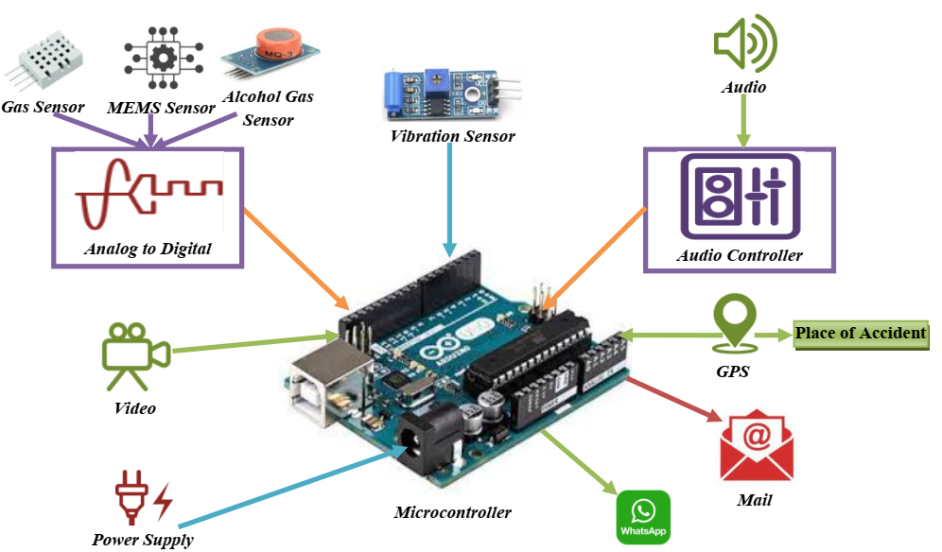
Fig. 1. System Model of the Proposed System

The GUI was created using the Python language, including a few packages that made it possible to handle various file types, create interfaces, as well as create executables that could run on many systems without having to install additional software [30]. With the help of this GUI, we were able to load the data and show it visually as well as quantitatively for text files. Players that are built into the GUI, as well as appropriate to every category, can be used to view videos and audio files. The GUI's goal is to make it easier to analyze the data gathered to identify the factors that led to mishaps as well as determine whether fault or mechanical issues with the automobile caused them [31]. The USB device for the Raspberry Pi is intrinsically linked to the USB camera. Digital pins connect the switch, the motor, and also the GPS. With the use of an image sensor, an image of the individual inside the car is taken in order to assess that individual's condition. The gas sensor can identify unusual gas flows or signs of intoxication within the car. The vehicle's inclination would be detected by the tilt sensor.

Working & Operations
This suggested work focuses mainly on the assessment of driveability as well as accidents. If the gas sensor's criterion quantity exceeds a certain degree, the car's position is automatically provided. It discusses the building of a theoretical model where each of the detectors is connected to an Arduino that uses IOT applications to transmit alert signals. It provides a quick summary of such a design that will be displayed in the suggested work. The gadget will snap a photo and use Nodemcu to communicate the position as an SMS to the Telegram channel as displayed in Fig. 2. The axis of the MEMS sensor is updated on the IOT Page. Tab. 1 represents the input and output of the proposed system.
Table. 1 Input and Output
Input | Output
Microcontroller | ATmega328P
Input Voltage Value | 5-12V
Input / Output Pins | 14
Analog Pins - I/P | 6 (A0 – A5)
Operating Voltage Value | 5V
I/P Voltage confines | 6-20V
DC I/O Pins | 40 mA
Memory | 32 KB
DC Current | 50 mA
Frequency | 16 MHz
EEPROM | 1KB

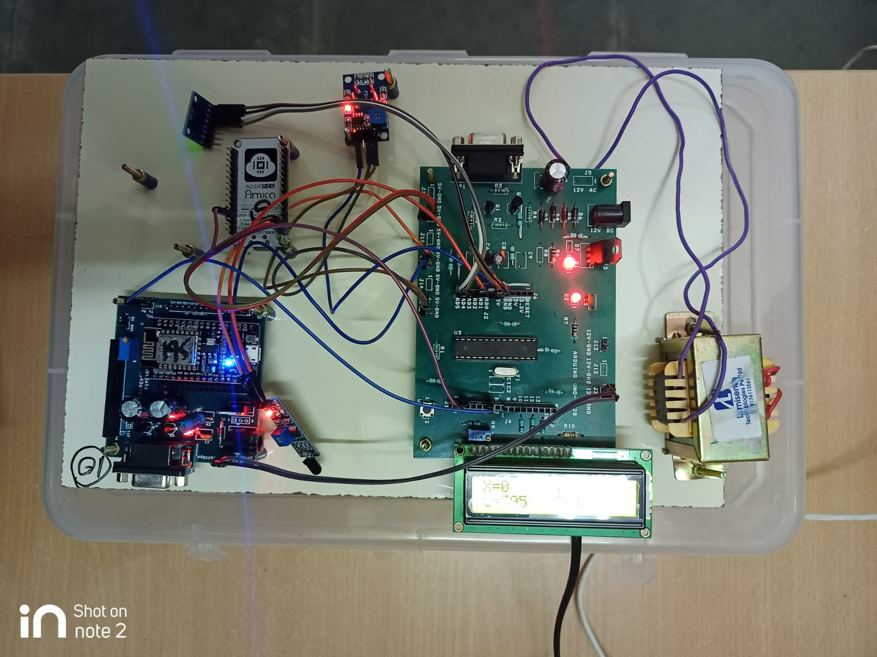
Fig. 2. Working Module of the Proposed System
Using the Arduino board uno, The digitalRead(), digitalWrite(), and pinMode(), as well as routines, allow you to use any one of the Uno's 14 microcontrollers as such an I/O. They use 5 volts to work. Every pin contains an inbuilt pull-up resistance of 20 to 50 k Ohms that is unconnected by default and provides a peak current capacity of 40 mA. Either an exterior source of electricity may be used to operate the Arduino. The foundation of energy is dynamically preferred. An AC-to-DC converter is one option for providing additional sources. A 2.1mm middle connector attached to the converter by place in to the panel's power connector. The pin GND and Vin connectors of the Voltage induced be capable of accepting power leads. The device could be powered by six to the 20-volt source. The 5V pin, meanwhile, can carry just under five watts if fed by means of much a smaller amount than seven volts, as well as the circuit could turn out to be unreliable. The charge controller possibly will overload as well as harm the circuit if enough above 12V is used. The suggested spectrum is between 7 and 12 volts. A pc and additional Arduino can all be communicated. On input pin 0 and 1, the ATmega328 enables socket interface. This communication protocol is routed by an ATmega16U2 upon that motherboard, by software like a simulated serial port.

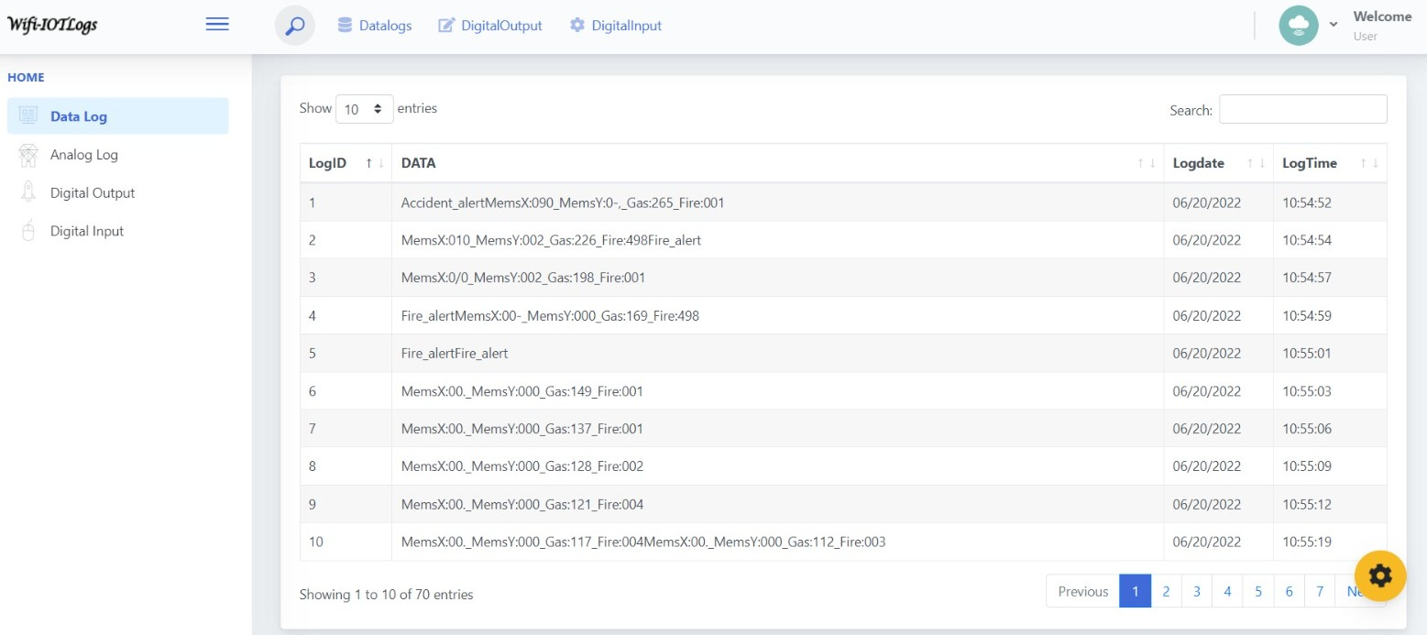
Fig. 3. Identifying Incidents Through the App

Simple text analytics can be delivered to in addition to received from the Arduino uno board by utilizing the serial communication found in the Arduino microcontroller. The Arduino Board has real-time conversation options that can be used to connect to a computer and other Arduino boards. The ATmega328 allows UART TTL (5V) port communication via input pins 0 (RX) and 1. (TX). An ATmega16U2 on that chipset routes this set of protocols through USB, which is viewed by applications as an emulated serial connection. The '16U2 firmware takes advantage of the integrated USB COM adapters, so no external program is needed. On Windows, however, an a.inf file is required. Through using the Uno microcontroller's sequential connectivity, simple text analyses may be sent to and obtained from the Arduino board.
The component's core is a low-cost, 6-axis MotionTracking microchip with a 4 mm x 4 mm packaging which integrates a motion detector, 3-axis gyroscope, and a DMP. It can detect rotational momentum along every three axes, the static velocity brought on by gravity, and the variable acceleration brought on by movement, impact, or disturbance. Since the module has a built-in LD3985 3.3V converter, you may use a 5V logic microprocessor like Uno without having any issues. Less than 3.6mA is consumed during measurement, and so only 5A is used while the MPU6050 is idle. Because of its low consumption, it can be used in battery-powered gadgets. The module also includes a power LED that turns on whenever the unit is activated. The MPU6050 unit is straightforward to set up and operate, as well as captures the device's essential output signals. Despite the numerous frameworks for utilizing the devices, it can be more challenging to manipulate the information into anything useful. Our model will snap a photo and use Nodemcu to communicate the position as an SMS to the user as shown in Fig. 3. Numerous data points representing temp, rotational motion, as well as positive linear correlation will be visible. Consider shifting your detector and observing how well the data changes. You may initialize the sensor instance built with the desired detection range before using it. A low-pass filters the gyroscope's data output. The switching frequency of such a filter can be altered using the bandwidth setting. The information is only slightly smoothed by removing noise at high frequencies when the bandwidth option is used. For our study, we've set the gyroscope frequency to 400°/s, the filtering frequency to 21 Hz, as well as the accelerometer frequency to 8G.

Conclusion
Our approach focuses on gathering data from crash recorders about how the vehicles moved before and after a collision. When an accident occurs, the police control center or a rescue squad will be notified right away with the auto identification number and individual contact information. Our research focuses on pre-accident surveillance, which offers significant advantages, including accident tracing and functions as an autonomous protection system. The effectiveness of our technology in accurately identifying incidents, determining their severity, and also locating vehicles showed promise. It is a cutting-edge system that has a security system. Through the mobile app, we are able to turn the engine ON/OFF. Our car can be tracked around the clock. To analyze the backup data, a graphical interface was eventually created.

References
- Ni Ni San Hlaing1, Ma Naing2, San San Naing1 “ GPS and GSM Based Vehicle Tracking System” International Journal of Trend in Scientific Research and Development (IJTSRD) Volume: 3 | Issue: 4 | May-Jun 2019.
- Mr. B.Hari Kumar ,Mr. Syeda Fathima Tehseen, Mr. Thanveer, Mr .Guntha Vamshi Krishna, Mr. Syed Mohisin Akram, “Vehicle Monitoring and Tracking Sysytem Using GPS ANS GSM Technologies” International Research Journal of Engineering and Technology, ISSN:2395-0056, Volume-03, Issue-04, April 2016.
- Mr.Chanjin Kang, Mr. Seo Weon Heo, “Intelligent Safety Information Gathering System Using A Smart Blackbox”, IEEE International Conference on Consumer Electronics, ISSN: 978-1-5090-5544, September 2017.
- A. Das, A. Ray, A. Ghosh, S. Bhattacharyya, D. Mukherjee and T. K. Rana, "Vehicle accident prevent cum location monitoring system," 2017 8th Annual Industrial Automation and Electromechanical Engineering Conference (IEMECON), Bangkok, 2017, pp. 101-105.
- Kumar, M. Anil, M. Venkata Suman, Yogesh Misra, and M. Geetha Pratyusha. "Intelligent Vehicle Black box using IOT." International Journal of Engineering & Technology (UAE)-SCOPUS March-2018 7, no. 2.7 (2018): 215-218.
- R Dimple, Nanda B S. “Design and implementation of smart black box system for gathering the safety information in vehicles”. International Journal of Advance Research, Ideas and Innovations in Technology. Volume 4, Issue 3, 2018.
- Dhinakaran D, Joe Prathap P. M, "Protection of data privacy from vulnerability using two-fish technique with Apriori algorithm in data mining," The Journal of Supercomputing, 78(16), 17559–17593 (2022).
- Priyanka S G, Sanchita, Shreya S Gowda, Sushma B, Dr. Reshma Banu. “Accident Detection and Emergency Rescue Alert System”. International Journal of Scientific Research in Computer Science, Engineering and Information Technology 2018, Volume 4, Issue 6.
- Ananth T S, Baskar M, Udhaya Sankar S M, R. Thiagarajan, Arul Dalton G, Pasupuleti Raja Rajeshwari, Aruru Sai Kumar, Suresh A, Evaluation of low power consumption network on chip routing architecture, Microprocessors and Microsystems, 82 (2021), https://doi.org/10.1016/j.micpro.2020.103809.
- S. Shahzad, U. F. Shaikh, A. A. Shaikh, P. K. Mathurkar. “Black Box in Car,” Vishwakarma Journal of Engineering Research, Volume 2 Issue 3, September 2018.
- L. Srinivasan, D. Selvaraj, D. Dhinakaran, T. P. Anish, "IoT-Based Solution for Paraplegic Sufferer to Send Signals to Physician via Internet," SSRG International Journal of Electrical and Electronics Engineering, vol. 10, no. 1, pp. 41-52, 2023.
- Rajeshwari Devi D.V, Krishnaveni M.S, Mandara V, M.D Shobitha, Anvitha Muthamma K.C, "Black Box for Automobiles," International Journal of Engineering Research & Technology (IJERT), Volume 9, Issue 12, 2021.
- T. Pragathi, K.Soundarya, S.Poornima, P.C.Siva Kumar, "Vehicle Tracking With Black Box System Using Android," International Journal of Scientific Development and Research (IJSDR), Volume 4, Issue 1, pp. 201-206, 2019.
- S.M. Udhaya Sankar, D. Dhinakaran, C. C. Deboral, M. Ramakrishnan, "Safe Routing Approach by Identifying and Subsequently Eliminating the Attacks in MANET," International Journal of Engineering Trends and Technology, vol. 70, no. 11, pp. 219-231, 2022.
- D. Selvaraj, S. M. Udhaya Sankar, D. Dhinakaran, T. P. Anish, "Outsourced Analysis of Encrypted Graphs in the Cloud with Privacy Protection," SSRG International Journal of Electrical and Electronics Engineering, vol. 10, no. 1, pp. 53-62, 2023.
- Gagana B R, Chethana H T, "Surveillance and Black Box for Car," EAI Endorsed Transactions on Internet of Things, Volume 5 | Issue 19, 2019.
- S.M. Udhaya Sankar, D. Dhinakaran, C. Cathrin Deboral, M. Ramakrishnan, "Safe Routing Approach by Identifying and Subsequently Eliminating the Attacks in MANET," International Journal of Engineering Trends and Technology, vol. 70, no. 11, pp. 219-231, 2022. https://doi.org/10.14445/22315381/IJETT-V70I11P224.
- R Dimple, Nanda B S. “Design an d imp lementation o f smar t black box system for gathering the safety information in vehicles”. International Journal of Advance Research, Ideas and Innovations in Technology, Volume 4, Issue 3,2018.
- Priyanka S G, Sanchita, Shreya S Gowda, Sushma B, Dr. Reshma Banu. “Accident Detection and Emergency Rescue Alert System”. International Journal of Scientific Research in Computer Science, Engineering and Information Technology 2018, Volume 4, Issue 6.
- Dhinakaran, D., Selvaraj, D., Udhaya Sankar, S.M., Pavithra, S., Boomika, R. (2023). Assistive System for the Blind with Voice Output Based on Optical Character Recognition. In: Gupta, D., Khanna, A., Hassanien, A.E., Anand, S., Jaiswal, A. (eds) International Conference on Innovative Computing and Communications. Lecture Notes in Networks and Systems, vol 492.
- S. Shahzad, U. F. Shaikh, A. A. Shaikh, P. K. Mathurkar. “Black Box in Car ”. Vish wak ar ma Jo ur n al o f En gin eer in g Resear ch www.v jer .in Volume 2 Issue 3, September 2018.
- Rolison, J.J.; Regev, S.; Moutari, S.; Feeney, A. What are the factors that contribute to road accidents? An assessment of law enforcement views, ordinary drivers’ opinions, and road accident records. Accid. Anal. Prev. 2018, 115, 11–24.
- P. Kirubanantham, Udhaya Sankar, S.M, C. Amuthadevi, M. Baskar, M. Senthil Raja & P. C. Karthik, An intelligent web service group-based recommendation system for long-term composition. J Supercomput 78, (2022), 1944–1960.
- K. Sudharson, A. M. Sermakani, V. Parthipan, D. Dhinakaran, G. Eswari Petchiammal and N. S. Usha, "Hybrid Deep Learning Neural System for Brain Tumor Detection," 2022 2nd International Conference on Intelligent Technologies (CONIT), 2022, pp. 1-6.
- Udhaya Sankar, S.M., Christo, M.S., Uma Priyadarsini, P.S. Secure and Energy Concise Route Revamp Technique in Wireless Sensor Networks, Intelligent Automation and Soft Computing, 35(2) (2023) 2337–2351.
- D. Dhinakaran, M. R. Khanna, S. P. Panimalar, A. T. P, S. P. Kumar and K. Sudharson, "Secure Android Location Tracking Application with Privacy Enhanced Technique," 2022 Fifth International Conference on Computational Intelligence and Communication Technologies (CCICT), 2022, pp. 223-229, doi: 10.1109/CCiCT56684.2022.00050.
- Tasneem, K.F.; Singh, G.; Ahmed, P.; Halder, S.; Ganguly, S.; Soni, S.P.; Rakhra, M. Affordable black box: A Smart Accident Detection System for cars. In Proceedings of the 9th International Conference on Reliability, Infocom Technologies and Optimization Noida, India, 3–4 September 2021; pp. 1–5.
- Udhaya Sankar S.M., Ganesan R., Jeevaa Katiravan, Ramakrishnan M., Ruhin Kouser R, Mobile application based speech and voice analysis for COVID-19 detection using computational audit techniques, International Journal of Pervasive Computing and Communications, Vol. ahead-of-print No. ahead-of-print. (2020).
- Jena Catherine Bel D, Esther C, Zionna Sen G B,Tamizhmalar D, Dhinakaran D, Anish T. P,"Trustworthy Cloud Storage Data Protection based on Blockchain Technology," 2022 International Conference on Edge Computing and Applications (ICECAA), 2022, pp. 538-543.
- G. Gomathy, P. Kalaiselvi, D. Selvaraj, D. Dhinakaran, A. T. P and D. Arul Kumar, "Automatic Waste Management based on IoT using a Wireless Sensor Network," 2022 International Conference on Edge Computing and Applications (ICECAA), 2022, pp. 629-634.
- Rahman, M.M.; Kabir, A.Z.M.T.; Khan, S.Z.; Akhtar, N.; Al Mamun, A.; Hossain, S.M.M. Smart Vehicle Management System for Accident Reduction by Using Sensors and An IoT Based Black Box. In Proceedings of the 8th International Conference on Electrical Engineering, Computer Science and Informatics (EECSI); 2021; pp. 277–282.

